# Membership Retention

Contents

Membership Retention 1

Revision History 2

Introduction 3

Column from 4

SQL of Count EACH individual member 6

SQL of Count entire membership as one single unit (1) 8

## Revision History

|  |  |  |  |
| --- | --- | --- | --- |
| **Date** | **Version** | **Author** | **Description** |
| August 25, 2014 | 1 | Chandler Xue | Initial |

## Introduction

To show the retention information about membership.

Obtain the members retention information during Retention Period which in the same package when select “Same package”

Obtain the members retention information during Retention Period which in the different package when select “different package”

Obtain the members retention information during Retention Period when select “Any package”

## Column from

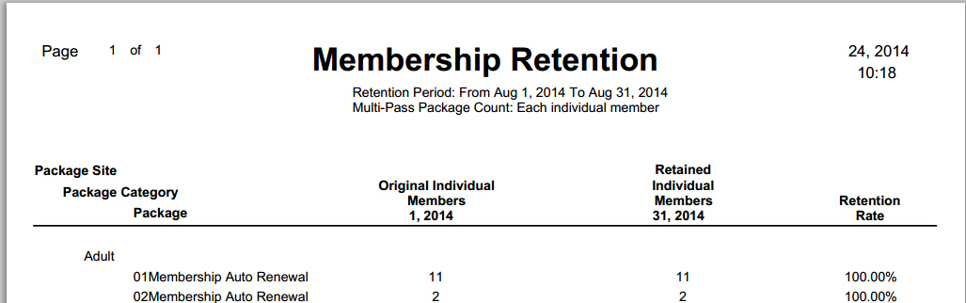

**Package Site** : The package’s site information, be empty if select “All Sites”

**Package Category** : The package’s category information

**Package** : The package’s name

**Original Individual Members** : The members amount in the package at the From Date of Retention Period

**Retained Individual Members** : The members amount in the package at the To Date of Retention Period

**Retention Rate** : Retained Individual Members/ Original Individual Members

**Related Database Tables**

**PACKAGES** : Record basic information of package, such as package name, category…

Package_ID is primary key

PackageCategory_ID is foreign key of relate to PACKAGE_CATEGORIES

Site_ID is foreign key of relate to SITES

**PACKAGE_CATEGORIES :** Record basic information of package category, such as package category name, category description…

PackageCategory_ID is primary key

**SITES :** Record basic information of site, such as site name, Address…

Site_ID is primary key

Geographic_Area_ID is foreign key of relate to GEOGRAPHIC_AREAS

POSLayoutID is foregin key of relate to POSLAYOUTPROPERTIES

**CUSTOMERS :** Record basic information of customer, such as customer name, Address…

Customer_ID is primary key

CustomerType_ID is foreign key of relate to CUSTOMERTYPES

Geographic_Area_ID is foreign key of relate to GEOGRAPHIC_AREAS

LastPayee_ID is foreign key of relate to ?

Site_ID is foreign key of relate to SITES

**CUSTOMER_MEMBERSHIP_DATES :** Record the relation between customer and the membership who enroll.

Customer_Membership_Date_ID is primary key

**AGE_CATEGORIES :** Record basic information of age restriction, such as lower age, upper age…

Age_Category_ID is primary key

**MEMBERSHIPS :** Record basic information of membership

Membership_ID is primary key

Package_ID is the foreign key of relate to PACKAGES

PrimaryMemberCustomer_ID is the foreign key of relate to CUSTOMERS

## SQL of Count EACH individual member

SELECT CUSTOMERS.customer_id AS customer_id,

PACKAGES.packagename AS packagename,

PACKAGES.package_id AS package_id,

SITES.site_id AS site_id,

SITES.sitename AS sitename,

PACKAGE_CATEGORIES.categoryname AS categoryname,

PACKAGE_CATEGORIES.packagecategory_id AS packagecategory_id,

(CASE

WHEN

(SELECT count(CUST.customer_id) AS c

FROM CUSTOMER_MEMBERSHIP_DATES "CUSTOMER_MEMBERSHIP_DATES"

RIGHT JOIN CUSTOMERS CUST ON CUSTOMER_MEMBERSHIP_DATES.customer_id=CUST.customer_id

JOIN MEMBERSHIPS MEMBERSHIPS ON CUSTOMER_MEMBERSHIP_DATES.membership_id=MEMBERSHIPS.membership_id

JOIN PACKAGES PACK ON CUSTOMER_MEMBERSHIP_DATES.package_id=PACK.package_id

LEFT JOIN PACKAGE_CATEGORIES PACKAGE_CATEGORIES ON PACKAGE_CATEGORIES.packagecategory_id=PACK.packagecategory_id

LEFT JOIN SITES SITES ON SITES.site_id=PACK.site_id

WHERE PACK.maxuses = 0

AND (customer_membership_dates.effective_date<={d '2014-08-31'}

AND customer_membership_dates.expiration_date>{d '2014-08-31'}

AND (termination_date = {ts '1899-12-30 00:00:00'}

OR termination_date >= {d '2014-08-31'}))

AND CUST.customer_id= CUSTOMERS.customer_id

AND PACK.package_id= PACKAGES.package_id) = 0 THEN '0'

ELSE '1'

END) AS retained

FROM CUSTOMER_MEMBERSHIP_DATES "CUSTOMER_MEMBERSHIP_DATES"

RIGHT JOIN CUSTOMERS CUSTOMERS ON CUSTOMER_MEMBERSHIP_DATES.customer_id=CUSTOMERS.customer_id

JOIN MEMBERSHIPS MEMBERSHIPS ON CUSTOMER_MEMBERSHIP_DATES.membership_id=MEMBERSHIPS.membership_id

JOIN PACKAGES PACKAGES ON CUSTOMER_MEMBERSHIP_DATES.package_id=PACKAGES.package_id

LEFT JOIN PACKAGE_CATEGORIES PACKAGE_CATEGORIES ON PACKAGE_CATEGORIES.packagecategory_id=PACKAGES.packagecategory_id

LEFT JOIN SITES SITES ON SITES.site_id=PACKAGES.site_id

LEFT JOIN AGE_CATEGORIES AGE_CATEGORIES ON CUSTOMERS.AGE_CATEGORY_ID=AGE_CATEGORIES.AGE_CATEGORY_ID

WHERE (customer_membership_dates.effective_date<={d '2014-08-01'}

AND customer_membership_dates.expiration_date>{d '2014-08-01'}

AND (termination_date = {ts '1899-12-30 00:00:00'}

OR termination_date >= {d '2014-08-01'}))

AND PACKAGES.maxuses = 0

ORDER BY sitename,

categoryname,

packagename

## SQL of Count entire membership as one single unit (1)

SELECT CUSTOMERS.customer_id AS customer_id,

PACKAGES.packagename AS packagename,

PACKAGES.package_id AS package_id,

SITES.site_id AS site_id,

SITES.sitename AS sitename,

PACKAGE_CATEGORIES.categoryname AS categoryname,

PACKAGE_CATEGORIES.packagecategory_id AS packagecategory_id,

(CASE

WHEN

(SELECT count(CUST.customer_id) AS c

FROM CUSTOMER_MEMBERSHIP_DATES "CUSTOMER_MEMBERSHIP_DATES"

RIGHT JOIN CUSTOMERS CUST ON CUSTOMER_MEMBERSHIP_DATES.customer_id=CUST.customer_id

JOIN MEMBERSHIPS MEMBERSHIPS ON CUSTOMER_MEMBERSHIP_DATES.membership_id=MEMBERSHIPS.membership_id

JOIN PACKAGES PACK ON CUSTOMER_MEMBERSHIP_DATES.package_id=PACK.package_id

LEFT JOIN PACKAGE_CATEGORIES PACKAGE_CATEGORIES ON PACKAGE_CATEGORIES.packagecategory_id=PACK.packagecategory_id

LEFT JOIN SITES SITES ON SITES.site_id=PACK.site_id

JOIN CUSTOMERS PMCUST ON MEMBERSHIPS.PrimaryMemberCustomer_ID=PMCUST.Customer_ID

WHERE PACK.maxuses = 0

AND (customer_membership_dates.effective_date<={d '2014-08-31'}

AND customer_membership_dates.expiration_date>{d '2014-08-31'}

AND (termination_date = {ts '1899-12-30 00:00:00'}

OR termination_date >= {d '2014-08-31'}))

AND CUST.customer_id= CUSTOMERS.customer_id

AND PACK.package_id= PACKAGES.package_id) = 0 THEN '0'

ELSE '1'

END) AS retained

FROM CUSTOMER_MEMBERSHIP_DATES "CUSTOMER_MEMBERSHIP_DATES"

RIGHT JOIN CUSTOMERS CUSTOMERS ON CUSTOMER_MEMBERSHIP_DATES.customer_id=CUSTOMERS.customer_id

JOIN MEMBERSHIPS MEMBERSHIPS ON CUSTOMER_MEMBERSHIP_DATES.membership_id=MEMBERSHIPS.membership_id

JOIN PACKAGES PACKAGES ON CUSTOMER_MEMBERSHIP_DATES.package_id=PACKAGES.package_id

LEFT JOIN PACKAGE_CATEGORIES PACKAGE_CATEGORIES ON PACKAGE_CATEGORIES.packagecategory_id=PACKAGES.packagecategory_id

LEFT JOIN SITES SITES ON SITES.site_id=PACKAGES.site_id

LEFT JOIN AGE_CATEGORIES AGE_CATEGORIES ON CUSTOMERS.AGE_CATEGORY_ID=AGE_CATEGORIES.AGE_CATEGORY_ID

WHERE (customer_membership_dates.effective_date<={d '2014-08-01'}

AND customer_membership_dates.expiration_date>{d '2014-08-01'}

AND (termination_date = {ts '1899-12-30 00:00:00'}

OR termination_date >= {d '2014-08-01'}))

AND CUSTOMER_MEMBERSHIP_DATES.customer_id = MEMBERSHIPS.primarymembercustomer_id

AND PACKAGES.maxuses = 0

ORDER BY sitename,

categoryname,

packagename